Agri – AI

About

AgriAI is a machine learning based application build using React and Flask. AgriAI is used for recommending Crop and Fertilizers based on the soil features. The application used three accurately prediciting models to make the final predictions.

An API was built using Flask and was deployed on Heroku. This Flask API is used to get the recommendation made by the machine learning models in JSON format. The input data is sent as a POST request to the API to get the predicted information.

Software’s Required:

* Python
* Flask
* React
* Node JS

Packages Installed:

* Npm

*These are the steps to run project using React in command prompt*

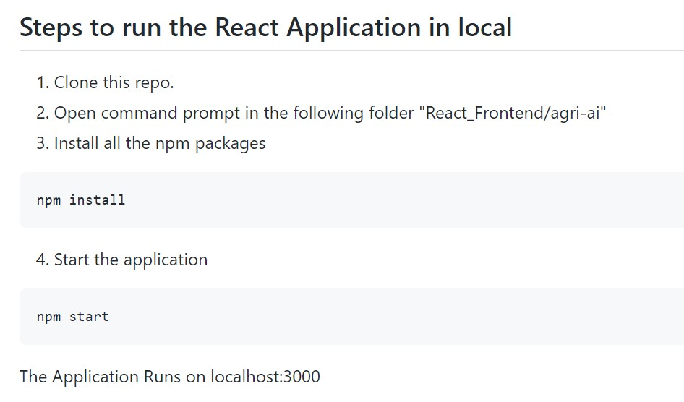

Step 1:

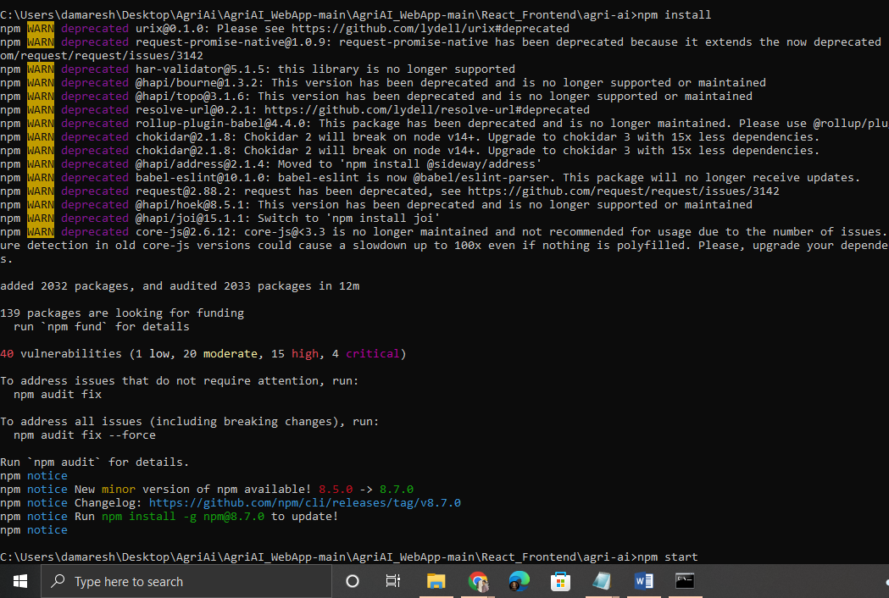

Step 2:

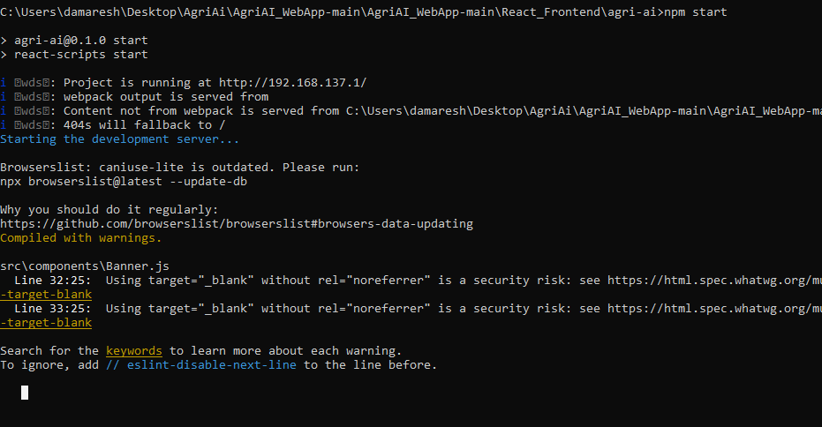

OUTPUT:

